GUIDELINES FOR THE ASSESSMENT OF
WELL DRAWDOWN ESTIMATES

FOR WATER RIGHT APPLICATION
PROCESSING
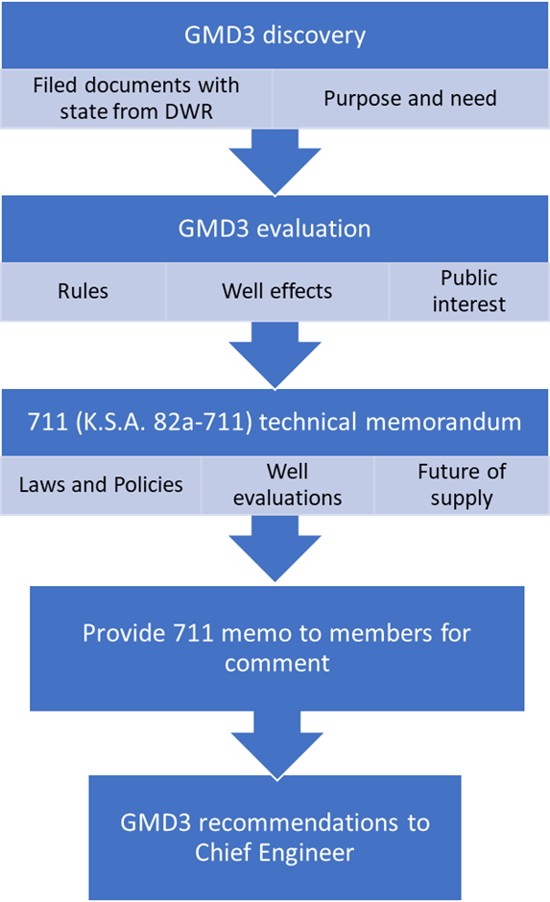

Southwest Kansas
Groundwater Management District No. 3
2019

Introduction
The chief engineer cannot grant an application to appropriate groundwater if the proposed appropriation will impair existing water rights (K.S.A.82a-711 & 82a-711a). Likewise, statutes governing changing location of well pumping (K.S.A.82a-708b, 82a-711 and 82a-711a), injunction for potential or actual impairment of prior rights (K.S.A.82a-717a), limited transfer permits (K.S.A. 82a-743) water conservation areas (K.S.A.82a-745), the GMD Act (K.S.A.82a-1020 et seq.) and administrative rule and regulation waivers (K.S.A. 82a-1904) all require that the chief engineer make a determination that the proposed action does not impair other water rights before approving an application. The statutes, however, do not define impairment. It is notable that the courts in Kansas have been active in defining impairment of a senior groundwater right by a junior groundwater right to be when that diversion diminishes, weakens, or injures the diversions of water under a prior right (Garetson Bros. v. Am. Warrior, Inc., 51 Kan. App. 2d 370, 389, 347 P.3d 687 (2014), review denied (Jan. 25, 2016)).

Impairment may result from the adverse impact created by the action proposed in an application on points of diversion of other groundwater rights (wells). Excessive groundwater-level drawdown at a well may adversely affect or prevent the exercise of the groundwater right(s) associated with the well. Therefore, part of the impairment evaluation involves estimating the drawdown at wells in the proximity of a proposed groundwater diversion.

Guidelines have been developed based on basic legal water use doctrine, hydrogeologic principles, and agency practice to provide guidance in assessing drawdown estimates for impairment determinations. Analyses of this nature always include uncertainty and data limitations, and accordingly must be applied on a case-by-case basis. Due to these factors, guidelines should include a reasonable level of conservatism, depending on circumstances and available data, to ensure the statutory mandate is met.

In addition to these drawdown assessment guidelines, other public interest considerations of the management program must be applied in the processing and review of water right applications. Those considerations are found in the management program document and other resources posted at: http://www.gmd3.org/

Drawdown Assessment Guidelines
The Drawdown Assessment guidelines provide a general approach to assess drawdown estimates on wells in the vicinity of a proposed diversion. Data availability and magnitude of drawdown control how the guidelines should be applied. Only a few steps may be necessary to reach a conclusion where drawdowns are de minimis, but additional steps may be necessary where the drawdown effects are larger or additional information can be discovered. A drawdown allowance defines a de minimis drawdown.

Fact finding. An assessment of drawdown begins by identifying the source aquifer, transmissivity (T), storage coefficient (S), and boundary conditions of the source aquifer for a given application. Values of T and S may be obtained from the following sources: hydrologic investigations by GMD3, state Division of Water Resources, Kansas Geological Survey, calibrated numerical models, and other sources. The values selected should be appropriate for the water bearing formations and thickness expected to be penetrated by the proposed well.

Theis calculation. A Theis analysis is typically performed, although numerical models may be used under the proper conditions, to assess 50-year drawdowns due to the proposed pumping schedule on nearby wells of other ownership, including wells owned by any protestant. The estimated drawdown is compared with a drawdown allowance (see Drawdown Allowance section below). If the predicted drawdown is less than or equal to the drawdown allowance, the impairment analysis in most cases may be concluded. Further work may be conducted for applications which have been protested (see Procedures section).

Drawdown allowance and critical wells. If drawdown allowance is exceeded (See drawdown allowance section and Table 1), further analysis is done to determine whether wells are critical wells under the proposal. A critical well is one likely to be impaired within 25 years. For this analysis, the proposed drawdown (DP), the existing drawdown (DE), and the dynamic drawdown (DD) are added together to calculate the total drawdown (DT). The DP is determined by a 25 year Theis analysis. The DE is determined using the GMD3 model or other appropriate better data to determine the likely water level decline over the next 25 years. The DD is the estimated drawdown within the well itself as it pumps. The three drawdown components are summed to obtain the total 25-year drawdown (Figure 1).

Economical constraint. Following drawdown estimation, an assessment of adverse impacts to existing nearby wells can be made by evaluating well records to select the amount of water level decline that existing wells may tolerate. As water levels decline, the pumping water level may descend to a level where well operations become uneconomical. Sterrett (2007) indicates (p. 429) that it is impractical to pump a well in an unconfined aquifer at a drawdown that exceeds 67 percent of the water bearing sediments. For administrative purposes, a decline rate not to exceed 40% in 25 years, or a value of 70 percent of the initial water column in 25 years is the economical drawdown constraint options for wells completed in unconfined and confined aquifers, whichever is more conservative, unless there is information to the contrary (Figure 2).

Physical constraint. In addition to the economical drawdown constraints, drawdowns can interfere with the physical production of groundwater. Factors such as the depth and thickness of the water bearing formation along with the pump and screen setting must be considered to assess the physical constraint (physical drawdown constraint). See Figure 3 and the Estimations section of this document for further explanation.

Most conservative constraint. The most conservative constraint, economical or physical, is the smaller of the two. The total drawdown is compared to the most conservative constraint to determine whether the wells of other ownership are capable of supplying water for a 25-year period from the date of application evaluation. If drawdowns exceed the economical or physical constraint, this may be grounds for impairment unless the drawdowns due to the proposed use are less than or equal to the drawdown allowance, or other options such as deepening the affected well(s) are available. In other words, a proposed well may induce a drawdown up to the most conservative constraint or the drawdown allowance.

Drawdown Allowance
Preventing any level of new impact on a well is impractical, as this would result in the denial of all applications including those causing relatively small or de minimis impacts. A drawdown allowance is used to define the relatively small impact due to a proposed diversion that may be allowed to occur on wells in which economical and/or physical constraints are exceeded. The drawdown allowance can be used as a screening tool to identify wells that require additional evaluation.

Recommended drawdown allowances are provided in Table 1. In general, the allowance is based on the magnitude of the current saturated thickness of the aquifer in the vicinity of an application in relation to the allowances adopted in the GMD3 guidelines. Special Groundwater Management Areas can be identified to include those areas in which there is a greater depletion rate than 40% in 25 years and the majority of the wells are critical. The values in Table 1 should be applied on a case-by-case basis for any type of geologic formation. If multiple applications have been filed in the same area it may be inappropriate to grant a succession of drawdown allowances on a given well.

TABLE 1
RECOMMENDED ADDED DRAWDOWN ALLOWANCE
FOR AREA WITH NO IMPAIRMENT CLAIM
AVERAGE AQUIFER THICKNESS IN THE VICINITY OF A PROPOSED WELL (ft) | TOTAL DRAWDOWN ALLOWANCE OVER 50 YRS (ft)
0 - 50 | 1.0
>50 - 75 | 1.5
>75 – 100 | 2.0
>100 – 125 | 2.5
>125 – 150 | 3.0
>150 – 200 | 3.5
>200 | 4.0

Saturated thickness can be calculated using the nearest monitoring well on the KGS network and local driller’s logs. If the proposed well has a log from a winter month, the water level indicated on that log will be used rather than the observation well’s water level. If there are no nearby monitoring wells, and there is no current water level from a driller’s log from a winter month, the GMD3 model will be used to estimate saturated thickness.

Estimations

Drawdown due to Proposed Use (DP)
The Theis equation is typically used to calculate 50-year drawdowns on nearby wells due to the use of a proposed well. Drawdowns calculated by a numerical model may be used but may not be representative of the actual conditions near a pumping well. This is typically the case if nearby wells are in the same model cell with the proposed well, or if the numerical model over-simplifies well spacing, which is generally the case for circumstances with boundary effects.

The selection of T, S, and boundary conditions should be based on available information and should be reasonable but conservative. If there is uncertainty regarding the aquifer properties or boundary conditions, the GMD3, DWR or KGS should be consulted. If the 50-year drawdowns are less than or equal to the drawdown allowance, no further work to assess impairment is necessary for most applications. Additional work may be conducted if an application is protested or additional information suggests otherwise.

For applications proposing a change to an existing water right (e.g. to change the point of diversion), the effects due to cessation of the move-from well or wells should be included in the analysis. The net drawdowns are obtained by finding the difference between the move-from and move-to effects. A similar approach may be used to compute the net drawdown for additional well applications.

When evaluating an additional well application, for a worst-case scenario, if no pumping distribution has been provided, assume the entire appropriation is derived from the proposed well. One can assume the well is capable of yielding the requested rate and quantity, then recommend a limitation if this poses a critical well problem. Information on well capacities for certain casing diameters may be obtained from Sterrett, Table 9.3 (2007). Information on capacities of the water bearing formations may be obtained from well records. If drawdowns exceed the economical or physical drawdown constraint on nearby wells, consider redistributing the pumping to each well and potentially placing limitations so that either the proposed pumping no longer exceeds drawdown constraints or no longer exceeds the drawdown allowance from Table 1. It may be worthwhile to contact the applicant in some cases to obtain information on the pumping distribution. If the applicant is requesting a new additional well because wells are failing, a greater percentage of pumping should be assigned to the new well. Keep in mind that requests for new additional wells are often made because well yields are inadequate and other GMD3 policy may be applicable.

Drawdown due to Existing Water Rights (DE)
Numerical groundwater models should be used to estimate 25-year water level decline due to the use of existing water rights. The model should accurately reflect present pumping rates of all wells and realistically project future rates and quantities pumped given declining water levels and aquifer properties. Calculations should be performed to assess the impacts of diverting the full amount of permitted, vested, adjudicated or certified rights. The amount associated with the beneficial use of domestic wells (K.S.A. 82a-705a) should be included in the analysis if not already included in model data.

Dynamic Drawdown (DD)
The dynamic drawdown represents the self-induced drawdown inside the casing of a well as the pump is cycled on and off. In some situations dynamic drawdown can be a significant portion of the total drawdown in a well. The procedure to estimate the dynamic drawdown depends on data availability. The options for estimating the dynamic drawdown in the order of preference follow.

- The dynamic drawdown may be measured directly by obtaining the water level when the well is pumping. This information may have been reported on a well record filed for the well in the section for additional statements. Aquifer tests also provide this information. Corrections to observed drawdowns may be necessary if the operational flow of the well is different from the amount permitted, licensed, adjudicated or declared. Corrections may be made by assuming drawdown is proportional to the pumping rate. For domestic wells, the flow rate Q should represent the permitted diversion in gpm at 60 percent production time (Q_{gpm} at 60 % = 1.03 x Q_{af/yr}) where domestics may be assigned an amount of 15 acre feet, unless other information dictates otherwise.

- The dynamic drawdown may be estimated if the specific capacity (SC) is available for the well. The specific capacity is the yield of well per unit of drawdown. The dynamic drawdown is equal to the flow rate Q in gallons per minute (gpm) divided by the SC in gpm/ft (DD = Q/SC).

- The Theis equation and well efficiency may be used to compute the dynamic drawdown. For non-irrigation wells, a radius of 0.50 feet and 60 percent of a day (864 minutes) for time should be used unless there is information to the contrary. The flow rate Q should represent the permitted diversion in gpm at 60 percent production time (Q_{gpm} at 60 % = 1.03 x Q_{af/yr}). Due to the variable nature of pumping schedules for irrigation wells, typically the drawdown at the end of the irrigation season is calculated assuming full time production during this period. Alternatively, if pumping schedules can be reasonably approximated the operational well yield may be estimated. The drawdown computed represents the water level decline in the aquifer adjacent to the well. To obtain the drawdown inside the casing (dynamic drawdown), the drawdown obtained from the Theis equation should be divided by a well efficiency of 70 percent (0.70) unless there is information to the contrary.

- It will be unnecessary to determine the dynamic drawdown for domestic wells if a minimum water column of 20 feet is assumed as the column required for operation (see Physical Drawdown Constraint section), unless data availability allows the estimation of dynamic drawdown and other components affecting the lowest practical pumping level (LPPL).

Total Drawdown (DT)
The estimated 25-year drawdowns due to the proposed use (DP), existing wells (DE), and self-induced dynamic drawdown (DD) are summed to obtain DT (Figure 1). The drawdown due to the use of existing wells represents the long-term average while the dynamic drawdown represents the instantaneous drawdown as pumps are turned on. Summing the two drawdowns together will produce some double accounting of drawdown, since drawdowns are computed twice for the same well, once in the existing well calculation and again in the dynamic drawdown calculation. However, the overestimation is probably offset by under-estimating the dynamic drawdown by assuming 70 percent efficiency. Lower efficiencies in some wells are expected, especially in older wells.

Water Column (WC)
The water column is the difference between the depth to the non-pumping water level (static water level) and depth to the base of the well screen, or production zone, whichever is higher in the well column. In the absence of well screen and production zone information, the total well depth may be used as the base of the water column. Water levels reported on well records may be updated using available water level data in surrounding wells to obtain the current water column. In the absence of field data to project the current water level, a model or water level reported in the well record may be used.

Economical Drawdown Constraint (EDC)
The economical drawdown constraint may be calculated one of two ways, whichever is more conservative. One way is based on the percent of initial water column that can be lost before the well loses economical viability. In the absence of more reliable data, a value of 70 percent of the initial water column loss in 25 years may be assumed as an economical drawdown constraint. An alternative EDC more typically used is a calculation of the rate of aquifer decline not to exceed 40% in the next 25 years (Figure 2).

Physical Drawdown Constraint (PDC)
Physical hardship. Physical hardship is the loss of the required well yield due to excessive water level decline. The physical drawdown constraint is the difference between the depth to the current static water level (or depth to the potentiometric surface) and depth to the LPPL. The LPPL depends on the availability of well completion information such as the depth and thickness of the water bearing zone or confining unit, pump setting, and screen setting.

Non-domestic wells. For non-domestic wells in an unconfined aquifer, the LPPL may be assumed at 40 feet above the top of the well screen or pump whichever is highest in the column, unless this assumption is unreasonable (Figure 3). The LPPL may also be assumed to be 60 feet above the base of the water column, if the screen interval or pump setting is unknown, unless this assumption is unreasonable. The LPPL for non-domestic wells in a confined aquifer may be assumed at the base of the upper confining unit unless this assumption is unreasonable (Sterrett, 2007). If the total drawdown extends below the LPPL that well becomes a critical well.

Domestic wells. Due to the relatively low volume of water produced by domestic wells, and other construction factors, some wells may be constructed with pumps set within the screen interval or close to the bottom of the well. The LPPL is typically assumed to be 20 feet above the base of the water column for domestic wells unless a different value is supported. At least 20 feet may be necessary to maintain submerged conditions, to allow a pump setting above the bottom to avoid sediment problems, and to allow for dynamic drawdown and other components (length of pump and net positive suction head).

Public Interest Constraint (PIC).
For the OHP Aquifer district wide, a maximum allowable rate of depletion has been used historically as a standard under the management program for more than 40 years. The GMD3 40/25 maximum allowable rate of depletion calculation will be used to insure any proposal will not result in exceeding nor increase and exceeding the rate of aquifer depletion.

Water Usability Constraint (WUC).
Usable water column for well evaluations can be significantly reduced by unusable water quality, or water usability depletion of supply. Usability constraints such as saltwater upwelling will be identified as available information may dictate.

Procedures
The list below provides a general description of the steps that may be required.

- Select the source aquifer, T, S, and boundary conditions.

- Estimate the current average saturated thickness of the source aquifer in the vicinity of the application and determine the drawdown allowance using Table 1. If the current thickness is unknown the thickness may be estimated based on a model or well records which show the saturated thickness encountered.

- Identify all wells within one mile of proposed well.

- If no wells are identified in which the 50-year drawdown due to the proposed diversion (DP) is greater than the drawdown allowance from Table 1 or other appropriate value, no further analysis is necessary (but Procedure Nos. 5 through 13 may be conducted if the application is protested).

For all wells in which 50-year drawdown due to the proposed diversion (DP) is greater than the drawdown allowance and for all wells owned by the protestant(s) regardless of their location, proceed with the following steps.

- Estimate the 25-year drawdown due to the proposed diversion (DP) on wells within one-mile radius of the proposed groundwater diversion. In addition, determine the 25-year drawdown due to the proposed diversion (DP) on wells owned by the protestants regardless of their location.

- Estimate the 25-year drawdown due to existing water rights (DE).

- Estimate the dynamic drawdown (DD) for each non-domestic well.

- Add the results from steps 5, 6, and 7 to obtain the total drawdown (DT) for each non-domestic well considered in the analysis (DT = DP + DE + DD).

- For domestic wells, add results from steps 5 and 6 to obtain the total drawdown (DT = DP + DE) if it is assumed that domestic wells require a minimum column of 20 feet for operation. For some cases, including an estimate of the dynamic drawdown in the calculation of total drawdown (DT = DP + DE + DD) may be appropriate if sufficient information is available to estimate the dynamic drawdown for a domestic well.

- Multiply the water column by 0.40 to obtain the 40%/25yr economical drawdown constraint (EDC) for each well considered in the analysis, or other as appropriate.

- Estimate the depth to the LPPL for each well considered in the analysis.

- Subtract the depth to the current water level (WL) from the depth to the LPPL to obtain the physical drawdown constraint (PDC) for each well considered in the analysis (PDC = LPPL - WL).
- If DT exceeds the economical (EDC) or physical drawdown constraint (PDC) on any well considered in the analysis, then the well is predicted to have less than a 25-year life and is classified a critical well. Since it has already been established that the drawdown due to the proposed well(s) exceeds the drawdown allowance for wells considered in this analysis, proceed to the Application of Results by Decision-Makers section. If no wells are identified where DT exceeds a drawdown constraint, no additional evaluation is necessary, unless other information dictates otherwise.

Application of Results by Decision-Makers
Although the use of a proposed well may cause drawdowns that exceed an economical or physical constraint plus the drawdown allowance, water right decision-makers may weigh other circumstances before rendering a decision. Several considerations are provided below that may influence decision-making.
One consideration is whether the nearby critical well is reasonably completed. This determination is made by considering the average water columns for wells of the same use (domestic or non-domestic) completed in the preceding 10-year period in the vicinity of a proposed well, unless some other time period is more appropriate. Critical wells that have water columns greater than or equal to 70 percent of the average may be considered reasonably completed, unless local information dictates otherwise. For example, for wells of a certain type of use with an average water column of 100 feet, the water column of a well with 70 feet or more would be considered reasonably completed. Excessive impact on a critical well that is not reasonably completed may not be grounds for impairment.

The presence of a reasonably completed critical well in which the drawdown allowance is exceeded may be considered grounds for impairment. However, before this finding can be rendered, additional factors should be considered such as whether the affected well can be deepened or replaced, and well age. The following guidelines are provided:

- Reasonably completed critical wells which are 25 years or less in age should not be expected to be deepened or replaced by the well owner because GMD3 guidelines attempt to preserve water for 25 years for these wells. Drawdowns on these wells which exceed the allowance may constitute grounds for impairment.

- If a reasonably completed critical well is more than 25 years in age and can be deepened into the same source as the original well, drawdowns that exceed the drawdown allowance may not be grounds for impairment.

- If a reasonably completed critical well is more than 25 years in age but cannot be deepened, drawdowns that exceed the drawdown allowance may be grounds for impairment.

- The decision that a critical well can be deepened or replaced should be based on evidence that deeper wells in the same source exist in the area and can produce the quantity and quality of water sufficient to fulfill the water right.

Decision-makers may also consider additional information provided by the applicant and/or the neighboring water right owner and/or the GMD3 management program when deciding on an application, such as a pumping schedule, a groundwater monitoring plan, corrective controls, or other information. Based on this information, it may be possible to grant conditional approval. Decision makers may consider other physical solutions to remedy impairment. These solutions may include, but not limited to, the connection of the affected party to the applicant’s water system or replacement of impaired wells by the applicant or other forms of mitigating hardships. It is important to include a reasonable process of member notification of the proposal and results of evaluation to receive additional information of practical experience operating the area wells and how that information should be incorporated into the fact-finding process for a recommendation and decision.

References

GMD3 Guidelines are adapted in significant part from: NEW MEXICO OFFICE OF THE STATE ENGINEER HYDROLOGY BUREAU REPORT 05-17
Morrison, Tom, 2006, Guidelines for the Assessment of Drawdown Estimates: New Mexico Office of the State Engineer, Hydrology Bureau Report 06-01.
Morrison, Tom, 2016, Guidelines for the Assessment of Drawdown Estimates: New Mexico
Office of the State Engineer, Hydrology Bureau Report 16-03. Sterrett, R. J., 2007.
Groundwater and Wells, Johnson Division, St.Paul, MN.
Groundwater and Wells, 2007, 812 pages, Robert J. Sterrett.

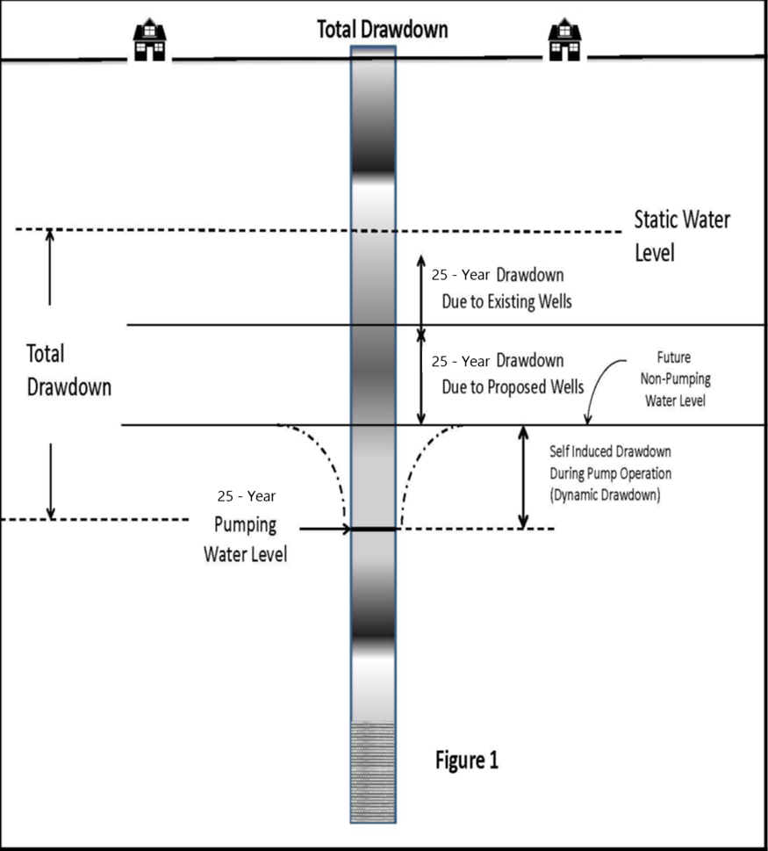
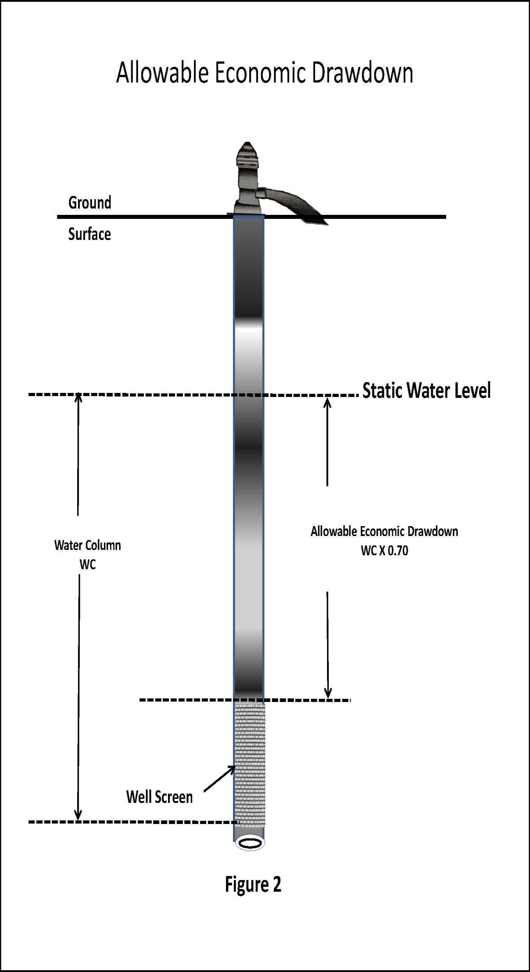
or a decline rate not to exceed 40% in 25 yrs.
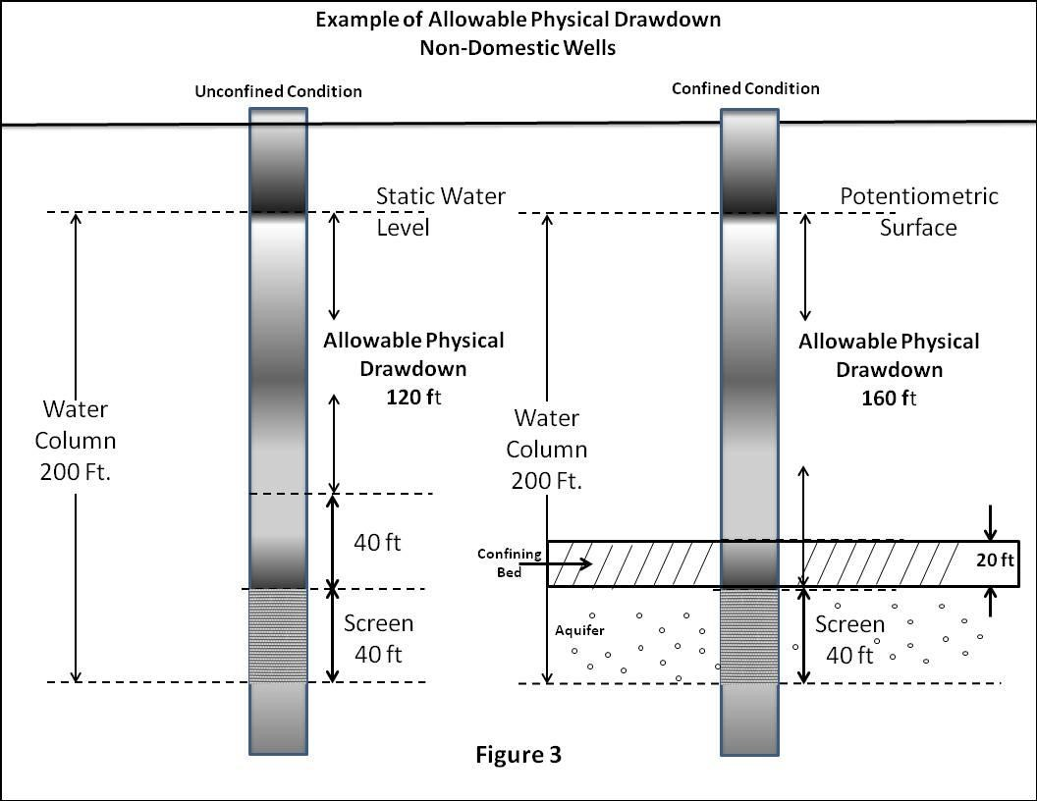

Wells in which economic and/or physical constraints are exceeded due to total 25-year drawdown are referred to as “critical wells”. Wells may become critical due to the use of existing water rights alone or the combined effects of dynamic drawdown, existing uses, and proposed uses if one or more of the drawdown constraints are exceeded.
If data are insufficient to determine the current thickness the thickness may be based on the average water columns obtained from area well logs.

