NRCS CONSERVATION INNOVATION GRANT
2017 Annual Progress Report

Grantee: Southwest Kansas Groundwater Management District No. 3

Project Title: A Demonstration and Evaluation of the Potential for Mobile Drip Irrigation (MDI) Technologies to Reduce Water Use and Extend the Usable Life of Groundwater Supplies

Agreement Number: 69-6215-15-0002

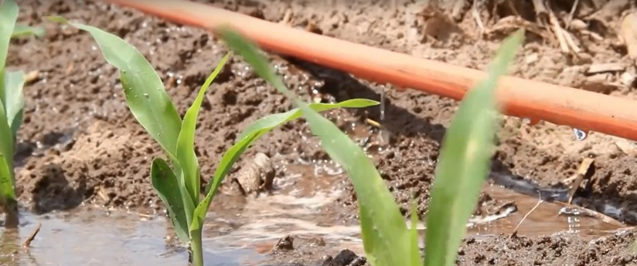
Project Directors: Trevor Ahring
Clay Scott
Mark Rude

Contact Information:
Phone: (620) 275-7147
E-Mail: trevora@gmd3.org
Address: 2009 E Spruce St.
Garden City, KS 67846

Period Covered by Report: 01/01/2017 – 12/31/2017

Project End Date: 09/30/2018

Project Status

There are 11 fields that have been equipped with mobile drip tape on the inner 3 spans or evaluation in the CIG project. These fields are located in the following sections, all within Stanton and Grant Counties, Kansas:

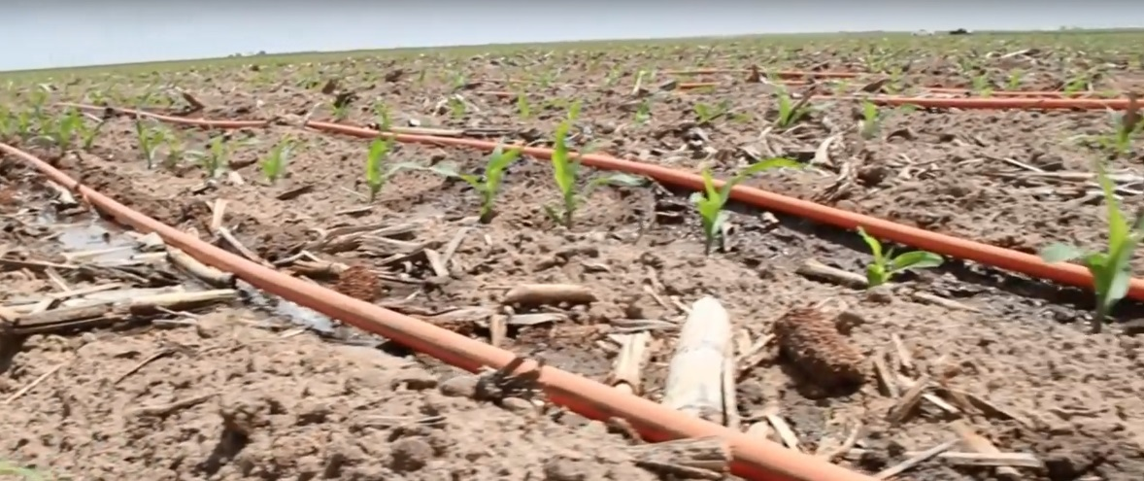
Sec 20-27-39
Secs 15-27-39 & 22-27-39
Sec 21-28-38
Sec 8-28-38
Secs 18-28-38 & 19-28-38
Sec 3-29-39
Sec 4-29-39
Sec 31-27-39
Sec 14-27-39
Sec 21-27-39
Sec 16-27-39

See Fig. 1 for a complete project map, including land with fully-irrigated corn, limited-irrigation corn, and irrigated wheat.

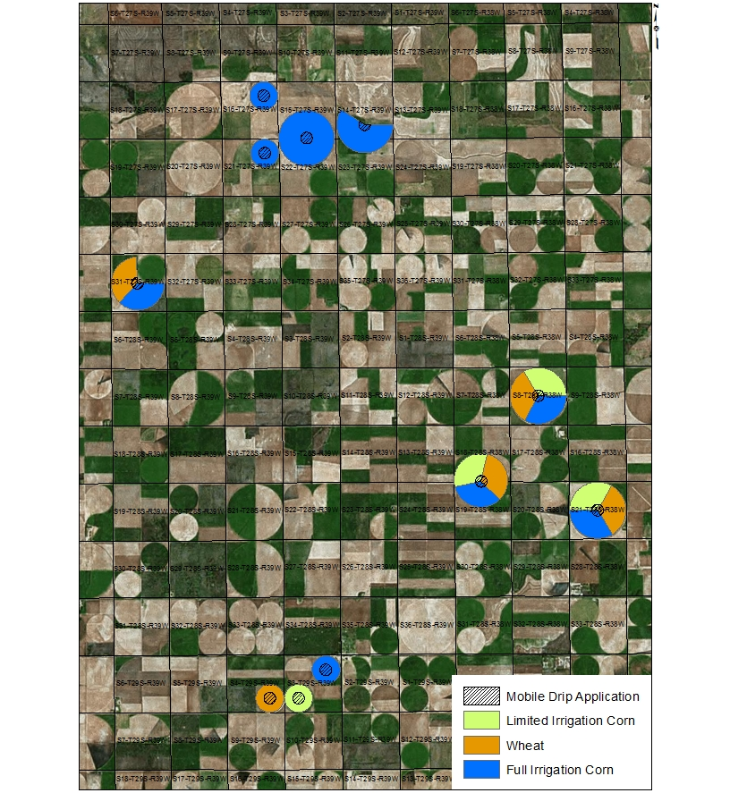
Figure 1. Project map. All fields located in Grant and Stanton Counties.

Each project field has been equipped with Dragon-Line® mobile drip irrigation technology on the inner three spans of a center pivot system. Irrigation was scheduled using soil moisture probes to maximize yield and minimize water use.

Field Inputs

Seeding Rate: All fully-irrigated corn ground was seeded at a rate of 28,000 spa. Limited irrigation corn ground was seeded at a rate of 19,600 spa. Irrigated wheat was seeded at a rate of 90 lb/ac.

Fertilizer: Fully-irrigated corn was fertilized with 225 lb N. Limited irrigation corn was fertilized with 160 lb N. Wheat was fertilized with 100 lb N.

Water: The summer of 2017 was wetter than normal, producing 25.25” rain. This high rainfall, combined with good management, allowed for project wells to be shut off through much of the summer.
Yields

Yield and irrigation data for each project field were as follows:

Section 31-27-39: 277 bsh/ac (fully-irrigated corn), 10.13 in. irrigation
69 bsh/ac (irrigated wheat), 10.13 in. irrigation

Section 14-27-39: 233 bsh/ac (fully-irrigated corn), 7.87 in. irrigation

Section 21-27-39: 231 bsh/ac (fully-irrigated corn), 14.5 in. irrigation

Section 16-27-39: 264 bsh/ac (fully-irrigated corn), 14.5 in. irrigation

SW ¼ Section 3-29-39: 230 bsh/ac (limited irrigation corn), 4.1 in. irrigation

NE ¼ Section 3-29-39: 252 bsh/ac (fully-irrigated corn), 6.1 in. irrigation

SE ¼ Section 4-29-39: 70 bsh/ac (irrigated wheat), 5.1 in. irrigation

Section 18-28-38: 251 bsh/ac (fully-irrigated corn), 4.2 in. irrigation
188 bsh/ac (limited irrigation corn), 2.3 in. irrigation
77 bsh/ac (irrigated wheat), 6.6 in. irrigation

Section 8-28-38: 240 bsh/ac (fully-irrigated corn), 4.31 in. irrigation
195 bsh/ac (limited irrigation corn), 2.34 in. irrigation
81 bsh/ac (irrigated wheat), 6.6 in. irrigation

Section 21-28-38: 230 bsh/ac (fully-irrigated corn), 2.11 in. irrigation
201 bsh/ac (limited irrigation corn), 3.00 in. irrigation
70 bsh/ac (irrigated wheat), 5.1 in. irrigation
*Note: The sprinkler fell down on this section, limiting water late in the season.

Section 15-27-39: 218 bsh/ac (fully-irrigated corn), 7.87 in. irrigation
*Note: The sprinkler fell down on this section, allowing no water through the month of July.

There were no significant yield differences on the acreage covered by mobile drip irrigation compared to the acreage covered by drop nozzles. This may have been because of the higher than average rainfall, or it might have been because the technology does not significantly affect yield.

Water Savings

For each of the project fields, nozzles on the inner 3 spans were replaced with mobile drip irrigation, covering 218 project acres. Of these acres, 126 acres were fully irrigated corn, with a total of 96.5 AF applied. Average application on fully-irrigated corn was 9.18” irrigation water. 50 acres were irrigated wheat, with a total of 26.4 AF applied. Average application on irrigated wheat was 6.33” irrigation water. 42 acres were limited irrigation corn, with a total of 11.6 AF applied. Average application on limited-irrigation corn was 3.31” irrigation water. The total water applied with mobile drip technology was 134.5 AF. All project wells are replacing nozzles in the inner towers that apply water at a rate 0.204 ac-in/hr with mobile drip irrigation that applies water at a rate of 0.126 ac-in/hr. The water use on those acres with the old drop nozzle packages would have been 217.8 AF. The total water savings for the 2017 project year were 83.3 AF.

Other Benefits

Replacing inefficient nozzles in the inner 3 spans improved the overall uniformity of pressure in the center pivot system, allowing nozzle size to be increased in the outer spans. This improved the rate of application without increasing the overall pumping rate, allowing the systems to be shut off for more days than they otherwise would have. This reduces operational cost and saves energy.

Work to be Completed

There is one year remaining for evaluation. Each project field will continue to be evaluated and GMD3 will create a fact sheet for public distribution, a draft practice standard, and a final report, including cost-benefit analysis.

